# **Template – Online Application with TabStrip and DocuSign**

The template named “Template – Campus University Online Application with TabStrip” is applicable to CampusNexus Student. This template creates a form with tabs for each step of the application process.

## Purpose and Outcome

This sequence is intended to be used by students who enroll into a program at your institution. This is an authenticated sequence that requires the user to have a Portal user name and password.

The application process involves collection of demographic information for the student, obtaining previous education information, collection of documents and necessary signatures using DocuSign, and managing other tasks and activities to enroll the student in a program. The information is used to create the applicant record for the student.

## Prerequisites

The template was built with Forms Builder using the applications listed below. The template is forward compatible with later versions of the listed applications.

|  |  |
| --- | --- |
| **Application** | **Minimum Version** |
| Forms Builder Designer and Renderer | 3.6.2 |
| Web Client for CampusNexus Student | 21.1 |
| Workflow Composer | 3.0.x |
| Packages installed from Package Manager in Workflow Composer | Activities and Contracts (V1) 21.1.0  Activities and Contracts (V2) 21.1.0  Forms Builder Contracts 3.6.x |
| Workflow Tracking Database | N/A |
| Staff STS 2.1 | 2.1 |

## Step 1: Download and Import the Template

1. Download the template file to your environment (local drive or network location).
2. Log into **Forms Builder** and select the **Form Designer tile**.
3. Click the **Export/Import** tile.
4. Select the **Import** tab.
5. Click **Select exported file** and navigate to the downloaded template file.
6. Click **Import**.

* [Export/Import](https://help.campusmanagement.com/FB/3.x/Content/ExportImport.htm)

### The following forms will be imported:

* Campus University Online Application - Campus Selection
* Campus University Online Application - Step 1
* Campus University Online Application - Step 2
* Campus University Online Application - Step 3
* Campus University Online Application - Step 4
* Campus University Online Application - Step 5
* Campus University Online Application - Step 6
* Campus University - Online Application with TabStrip
* Default-Frame
* Custom - Confirmation Standard No Auto Close

## Step 2: In Form Designer…

1. From the Forms slide out, select **Campus University Online Application - Campus Selection**.
2. Customize the form for your environment. Modify field/component properties or add/remove fields/components.
3. Repeat steps 1 and 2 for the following forms:

**Campus University Online Application – Step 1**

**Campus University Online Application – Step 2**

**Campus University Online Application – Step 3**

**Campus University Online Application – Step 4**

**Campus University Online Application – Step 5**

**Campus University Online Application – Step 6**

1. From the Forms slide out, select **Campus University - Online Application with TabStrip**.
2. Click the **TabStrip** component in the Layout pane.
3. Click the **Edit** button in the Control Property Settings pane. Customize the **Tab Labels** for your institution.
4. After you have completed the tab configuration, click **Save**. The TabStrip Configuration window is closed.
5. Optional - Customize additional settings for the TabStrip component in the Control Property Settings pane.

* [Fields](https://help.campusmanagement.com/FB/3.x/Content/Fields.htm) and [Components](https://help.campusmanagement.com/FB/3.x/Content/Components.htm)

## Step 3: In Sequence Designer…

1. Select the **Campus University Online Application with TabStrip** sequence.
2. Click **Save As** to create a copy of the sequence/workflow and customize the copy for your use. This way you can always refer to the original sequence/workflow you downloaded.
3. Optional - Customize the sequence properties for your environment.
4. Optional - Add a custom style (theme) associated with your campus.

* [Themes](https://help.campusmanagement.com/FB/3.x/Content/Themes.htm)

1. Open the sequence workflow. Depending on your environment, either click **Open Workflow** in Sequence Designer or launch a local installation of Workflow Composer.

* [Opening Workflows for Sequences](https://help.campusmanagement.com/FB/3.x/Content/HostedEnv.htm)

## Step 4: In Workflow Composer…

1. Open the **Campus University Online Application with TabStrip** workflow. This is a state machine workflow. Each form is a state. The arrows are transitions from one state to another.

* [State Machine Workflows](https://help.campusmanagement.com/FB/3.x/Content/StateMachineWorkflows.htm)

1. Select the **Arguments** tab and note that the following arguments have been created due to entity fields on form.

* applicantEntity
* highSchoolEntity
* studentEntity
* studentPreviousEducationEntity
  + [Updating a Form After Creation of a Sequence](https://help.campusmanagement.com/FB/3.x/Content/AddingEntities.htm) and [Components](https://help.campusmanagement.com/FB/3.x/Content/Components.htm)

1. Double-click the **Campus University - Online Application with TabStrip** state and expand the **Find Student** sequence. This sequence contains the following workflow activities:
   * LookupUser (labelled “Lookup Student”)
   * GetEntity<StudentEntity>
   * Assign (labelled “Assign Address Association”)
   * LookupReferenceItem
   * LookupStudentDocuments
   * Sequence labelled “Create Applicant Record” with the following activities:
     + CreateEntity<ApplicantEntity>
     + Assign (labelled “Assign School Status”)
     + Assign (labelled “Assign Admissions Rep”)
     + Assign (labelled “Assign Applicant Type”)
     + Assign (labelled “Assign Enroll Status”)
     + Assign (labelled “Assign Campus”)
     + Assign (labelled “Map Student”)
     + Assign (labelled “Add Comment”)
     + CreateEntity<StudentPreviousEducationEntity>

You will need to modify the hard-coded assignment values for your CampusNexus Student environment as described in the following steps.

1. Expand the **LookupReferenceItem** activity. Select the **Reference Item** **Type** you are looking for (e.g., Document Type) and then select the Item you are looking for within that Type (e.g., Application for Enrollment). The activity will return the hard-coded Id value (e.g., 59).

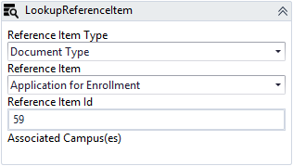

* + [LookupReferenceItem activity](https://help.campusmanagement.com/WF/Content/Workflow/LookupReferenceItem.htm)

1. Update the following **Assign** statements as appropriate for your environment using database queries or additional LookupReferenceItem activities.
   * Assign (labelled “Assign School Status”)
   * Assign (labelled “Assign Admissions Rep”)
   * Assign (labelled “Assign Applicant Type”)
   * Assign (labelled “Assign Enroll Status”)
   * Assign (labelled “Add Comment”)
2. Click the **Submit** transition that leads to the Default-Frame.

This section assigns values to the studentPreviousEducationEntity, logs the data for this entity and then saves the applicant, student, and student previous education entities.

We are also updating some values in the applicant record that we discovered are not getting updated by the service. We do this by using the ExecuteDataReader and ExecuteQuery activities. We are also validating the form data upon Save.

You do not need to modify any activities in this section.

1. Click the **Default-Frame** link at the end of the Submit transition.

This section assigns the information needed to create the PDF file of the application form and populates the DocuSign activities and assignments.

You do not need to modify any activities in this section.

If you modified any form names, you need to update the URL value accordingly.

1. Click the **Submit** link at the end of the Default-Frame section. The student will select Submit when the DocuSign process is complete. The workflow takes the signed PDF and updates the document center in the CampusNexus Student database accordingly.

This workflow section checks if the document is assigned to the student record.

* If it is, the workflow updates it by inserting and attaching the signed PDF and updating the document status.
* Otherwise, the workflow creates the document, attaches the signed PDF, and updates the document status.

Based on the values configured in your database:

* Modify the **CreateDocument** activity to select an appropriate Document Status.
* Assign a value for the **DocumentEntity.DocumentStatusId**.

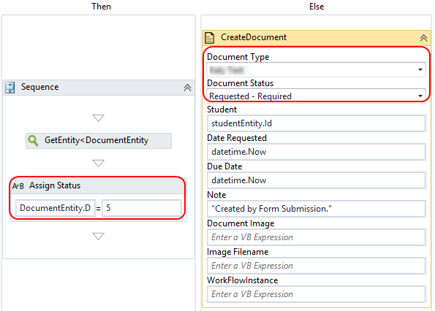

1. Click the **Publish** button in the ribbon of Workflow Composer. Select the check box **Enable This Workflow Version?** and click **Publish.**
   * [Saving and Publishing Workflows](https://help.campusmanagement.com/WF/Content/Workflow/PublishWorkflow.htm)

## Step 5: In Forms Renderer…

Select your sequence and try it out!

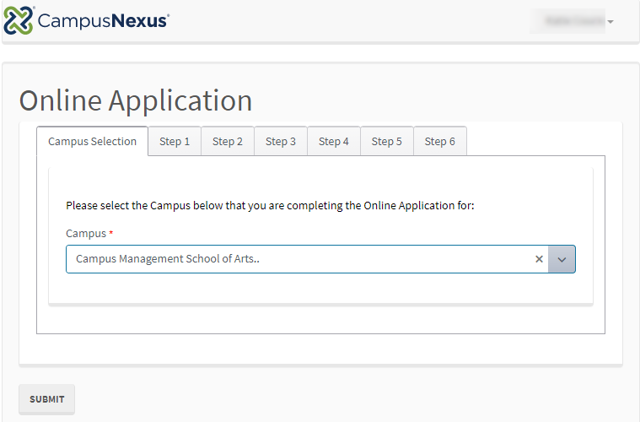

Upon completion of the application form, the student record in the database should be updated to a “Pending Applicant” status and the application document should be stored under in Contact Manager with today’s date.

* [Sequence List](https://help.campusmanagement.com/FB/3.x/Content/SequenceList.htm)

## Step 6: Lastly…

Once your updated sequence has been tested successfully, it is recommended that you disable the workflow for the original Template version.

1. In Workflow Composer, in the Server section of the ribbon, click **Open**.
2. Find the workflow named **Template – Campus University Online Application with TabStrip**.
3. Clear the **Enabled** check box and click **Save**.